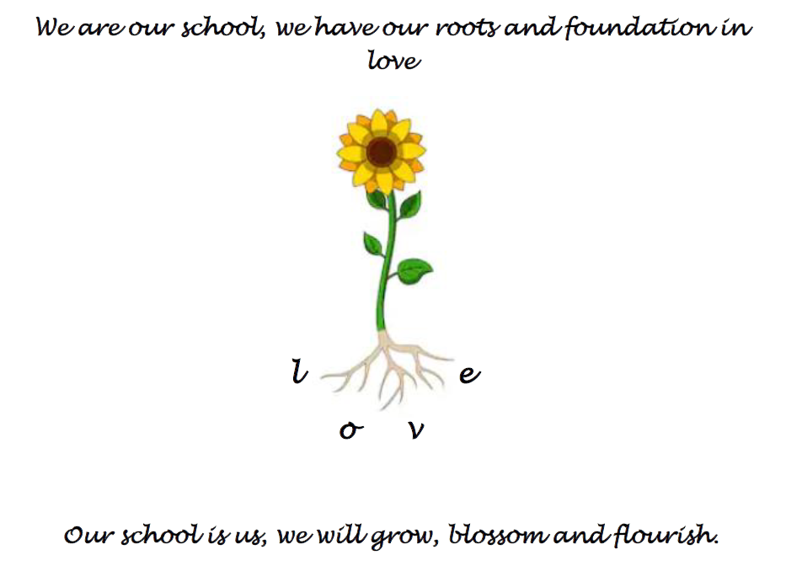
They say that it takes a village to raise a child and I think this is very true here at North Stainley. I arrived here in September 2019, our year four children were just beginning in reception and the then Year 6 children are now doing their GCSE’s. Within my first few weeks I realised that I was somewhere different to the village schools that I had been used to working in. You have this amazing community in the village, a community that looks after each other and strives to make this such a wonderful place to live in and to work in. Jane Mansell and members of the church community welcomed me with such warmth supporting my work here consistently from the very beginning. Glenys and Frank and the Village Trust have always ensured that having a split site worked seamlessly, giving myself and school priority, particularly during the pandemic. Other groups in the village including the Supper Club, the Arts Club and the Cricket Club have always tried to be involved or to involve the school making such positive contributions to school life. James Staveley and Light Water estates have supported the school not only financially but have also been on the end of the telephone when I have needed help, be it ground works, forest school resources, even moving a shed for us. This village’s support has been immeasurable.
However, I believe that the school is the beating heart of this village. The school community within is what makes that heart strong. Nat and all of our governors thank you, you give up your time unconditionally and work tirelessly for the school and you have been a constant support to me. Mike, Lindsay, Sarah and Richard, all of FONSS thank you, you work incredibly hard to keep the money coming in for all those extras and enrichments, I have only had to pick up the phone and you have been there to support and add the sparkle to both teaching and to learning in school.
To my colleagues and friends- Maggie, Sally, Laura-Mae, Jac, Carol, Jess, Laura, Meg, Jennie, Rachel, Natasha, Sarah, Elisa. To those of you who were here at the beginning, thank you for welcoming me with open arms four and a half years ago. Thank you for your devotion to your work that has enabled me to do mine so much more easily. Thank you for donning the very many hats that are required of teachers and for doing so with such good grace. I really have had the honour of working with the most fantastic team and I will miss you.

And of course, the reason that we are here; you children. Every single one of you is amazing. You are really what makes our school incredibly special. On occasions too often to count, visitors have come into school and within minutes have been wrapped in the warm embrace of the children in our school. I have been so proud when so many people have commented on how fantastic you all are, you are the embodiment of our school’s vision of love, so caring and respectful. You all strive with aspiration to do your very best in the life and in your learning in school. You have made my job an absolute pleasure, first thing in the morning when you walk/run into the playground, last thing in the afternoon as I see you go home and all of those wonderful, wonderful bits in between and I am going to miss seeing you all so much.
I know that as you all grow, you will also all blossom and all flourish and you will all become amazing people because you all have so much to offer this world.
So, thank you so much North Stainley School and North Stainley Village. It has been a joy!!

