Key Vocabulary

**Food Label**: tells you how much salt, sugar and fat is in the food.

**Balanced Diet:** contains food from each food group that keeps us healthy.

**Texture:** foods can be soft, hard, crunchy or lumpy.

**Appearance:** the way the biscuit looks.

**Cream**: mix the butter and eggs

**Packaging:** materials used to wrap the product.

**Hygiene**: keeping things clean.

Key Knowledge

I can research different products and packaging and suggest who the target audience would be.

Investigate and analyse existing products.

Select and use a variety of equipment for a task.

Know some ways to prepare ingredients safely and hygienically.

Gather information about needs and wants for an individual or a group.

Develop own criteria and use these to inform their idea.

I can make decisions that take into account resources.

I can explain the design features that will appeal to the intended users.

Select and use a variety of equipment for a task.

Know some ways to prepare ingredients safely and hygienically.

I can evaluate the design and taste of the biscuit and make suggestions on how it can be improved

Class 2- DT Knowledge Organiser Summer Term 1, Year A

How can we make an appealing biscuit for our packed lunch?

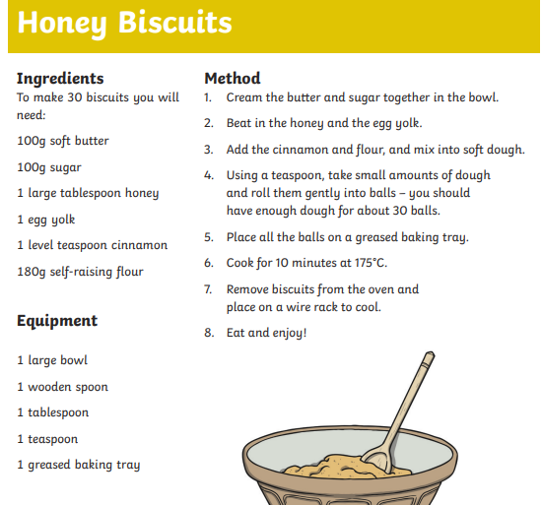

**Food Label/ Nutrition Label:** You can use the food label to find out how much fat, sugar and salt is in the food.

