Key Vocabulary

**Tint:** a colour is added to white to create a lighter version of that colour.

**Shade:** black is added to a colour to darken it.

**Tone:** when grey is added to a colour.

**Still Life:** A painting of something that you can see in real life but it doesn’t move, like a bowl of fruit.

**Shadow**: a dark area created when something blocks the light.

**Dabbing**: paint I dabbed onto the surface with a brush, sponge, paper towel.

**Stippling**: apply tiny dots onto the surface to create texture.

**Washes**: watered down paint applied over the surface.

**Pointilism**: use tiny dots of different colours which blend together.

Class 2- Art Knowledge Organiser Summer Term 1, Year A

How can we use painting techniques to create a 3D effect?

Key Knowledge

I can explain the difference between a tint, a shade and a tone.

I can mix tints and shades of a colour.

I can use tints and shades to give a three-dimensional effect when painting**.**

I can explore how paint can create very different effects.

I can explain which techniques I have used to get a 3D effect.

I can tell you some facts about the life of Paul Cezanne and his style of painting.

I can create a still life arrangement inspired by Paul Cezanne.

I can create a still life painting inspired by the work of Paul Cezanne.

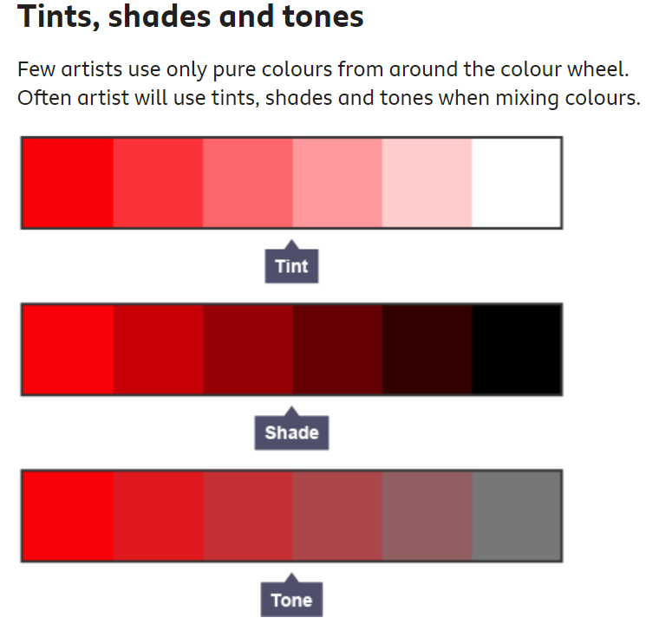

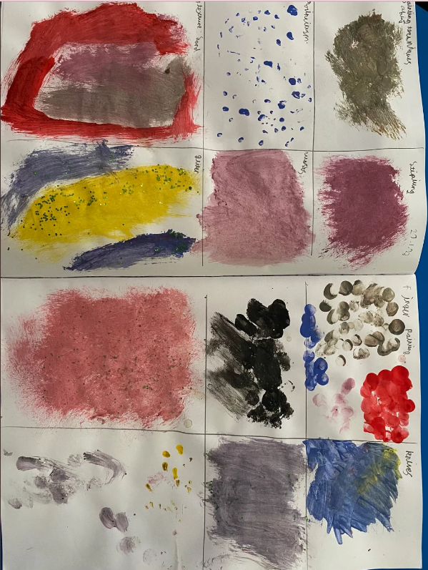

You can use paint to create different effects: dabbing, stippling, pointillism, washes, add different textures or use different tools.

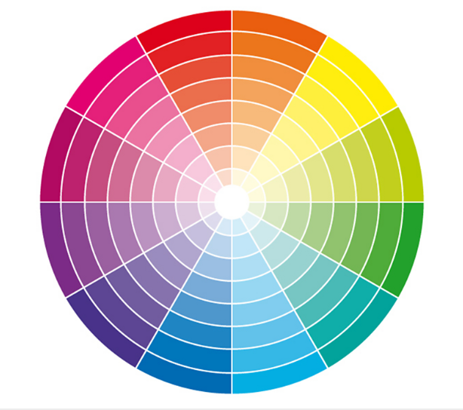

The Colour Wheel

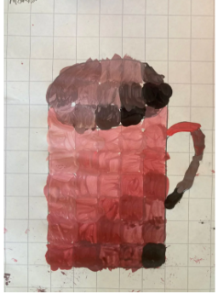

Tints and shades can be used to paint a 3D effect.

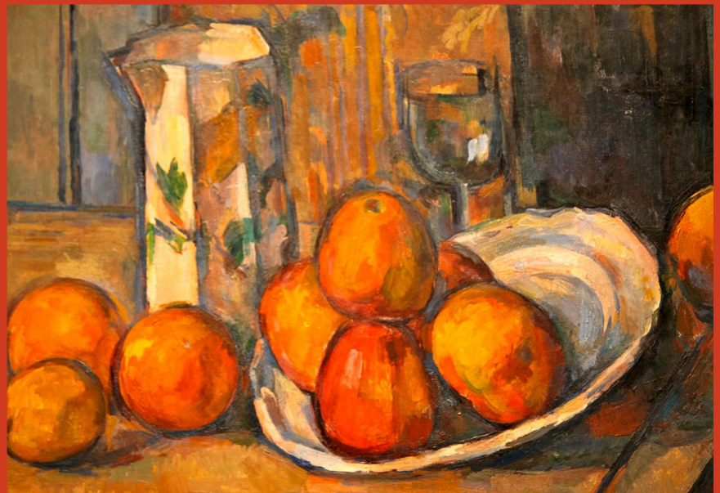

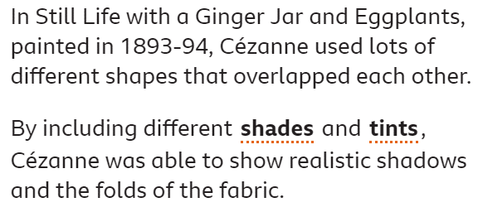

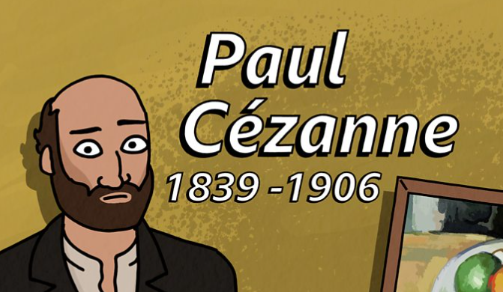

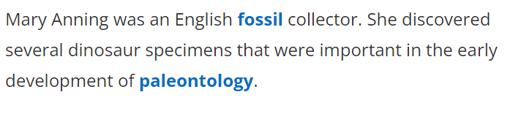

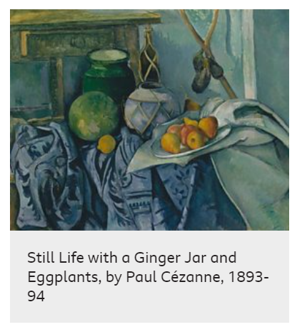

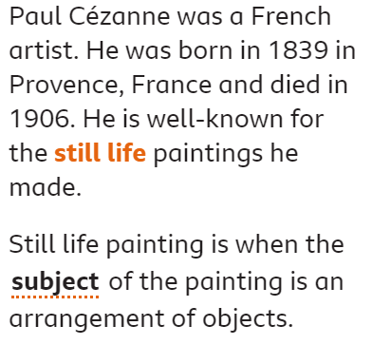

Still Life with a Fruit Basket, (1888-1890)

