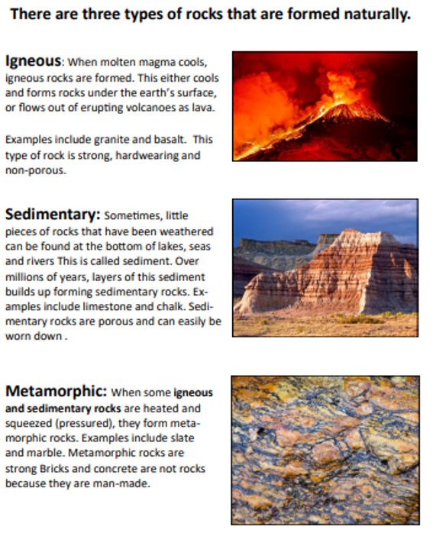

Class 2- Science Knowledge Organiser Spring Term, Year A **Rocks and Soils**

Key Vocabulary

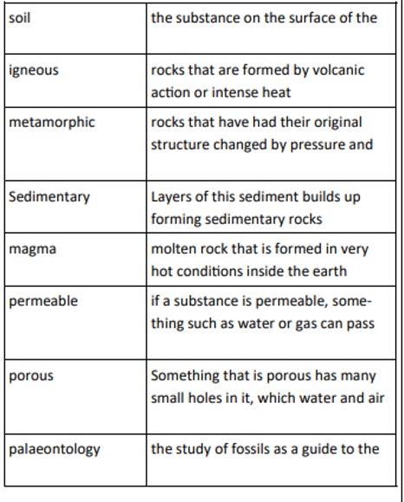

Key Knowledge

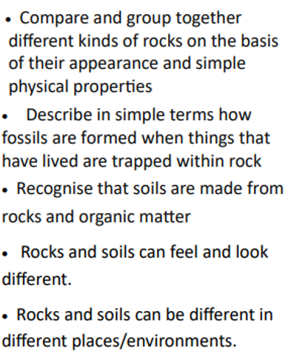

**Understand that scientific ideas change over time.**

Explain the contribution that Mary Anning made to palaeontology.

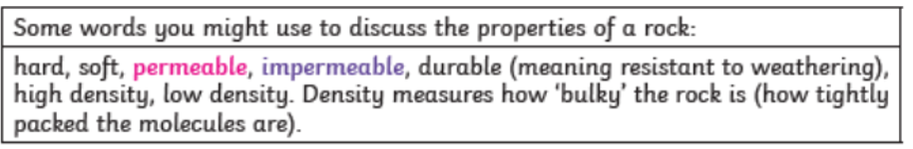

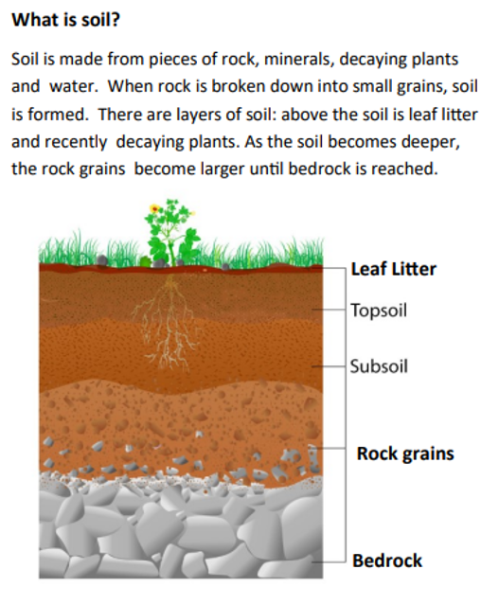

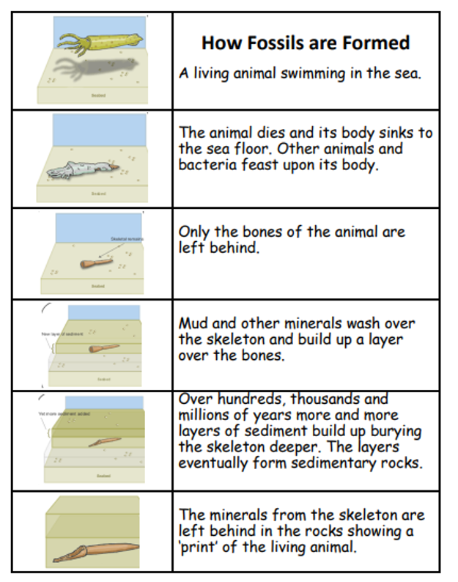

**Mary Anning**

21/5/1799- 9/3/1847

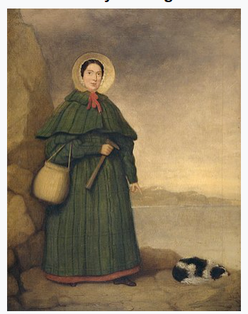

Mary Anning was as English Fossil collector. She discovered several dinosaur specimens that were important to the development of early palaeontology.

