Class 2- PSHE Knowledge Organiser Summer Term 1, Year A

**How can I make informed choices about a healthy lifestyle?**

Key Vocabulary

**Healthy**: in a good physical or mental condition.

**Unhealthy:** harmful to health

**Balanced Diet:** contains food from each food group that keeps us healthy.

**Carbohydrates:** give us energy

**Proteins:** help our bodies to grow and repair themselves.

**Fats:** help store energy for our bodies.

**Fibre:** helps us digest food.

**Balanced Lifestyle**: makes room for exercise, nutrition, sleep, that keeps our minds sharp and bodies strong.

**Choice:** an act of choosing between two or more possibilities.

**Decision:** choosing what to do from possible choices and arriving at a solution for a given problem.

**Peer Pressure**: influence from friends.

Key Knowledge

I can explain what you can do to keep healthy.

I can sort food into the different food groups and explain what they provide for the human body.

I can explain what is meant by a balanced diet.

I can explain what makes a balanced lifestyle.

I can explain the choices and decisions I make every day.

I can explain how some choices can have short term/ long term effect on our lives.

I can reflect on who helps me make a choice.

I can explain the difference between a healthy and an unhealthy choice.

I can explain the 5 ways to well being and how they help me to keep my body and mind healthy.

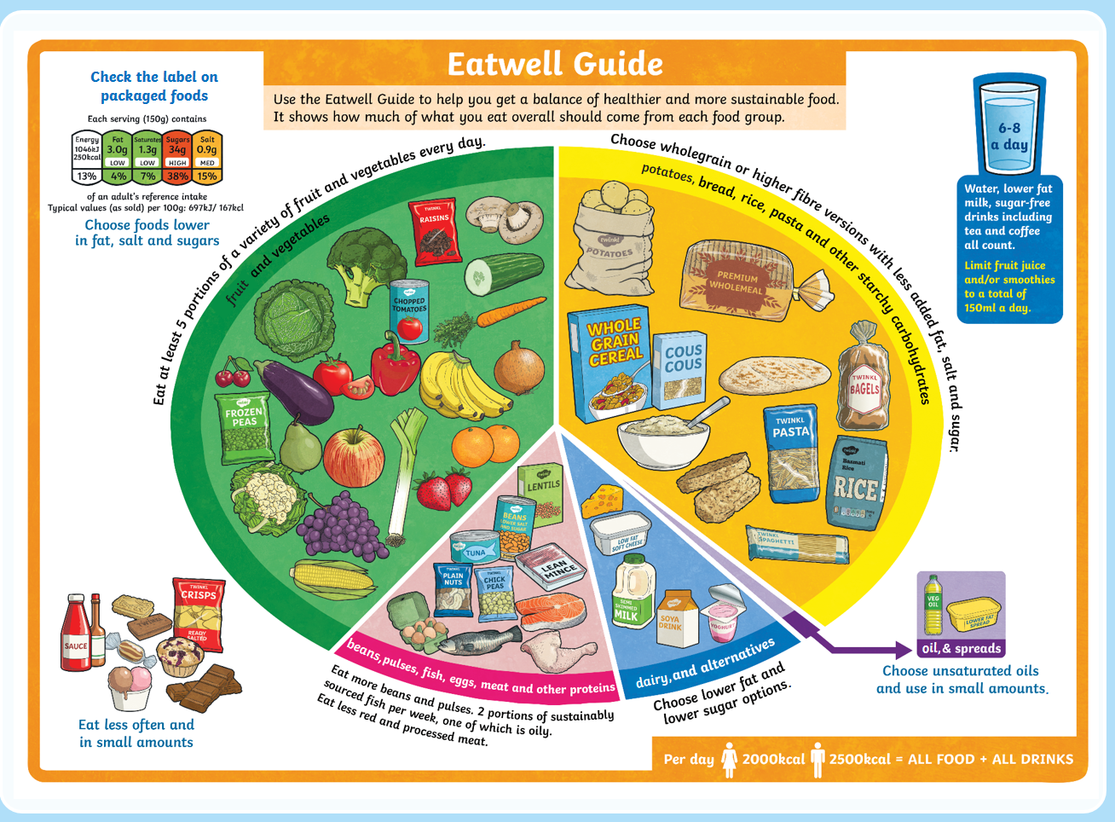

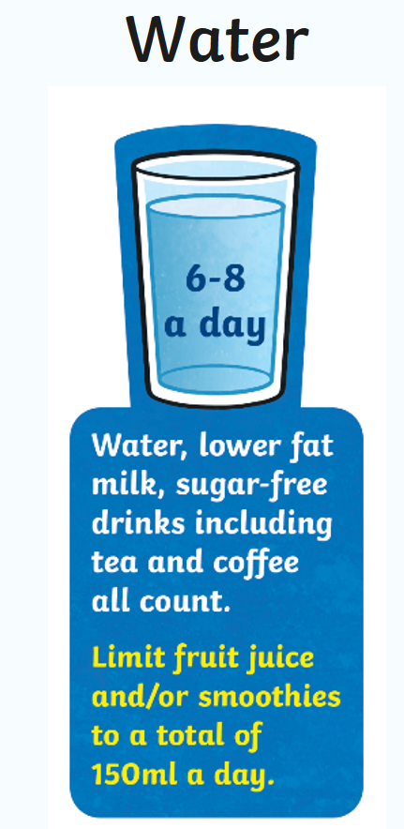

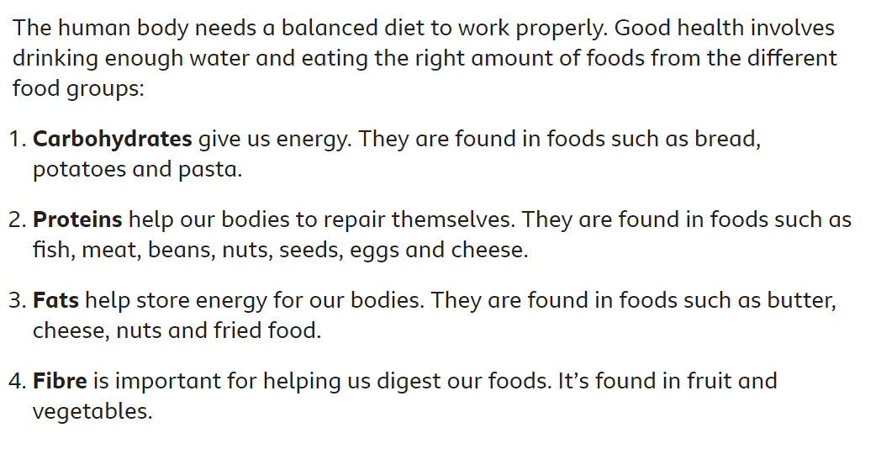

**The Five Ways To Wellbeing**



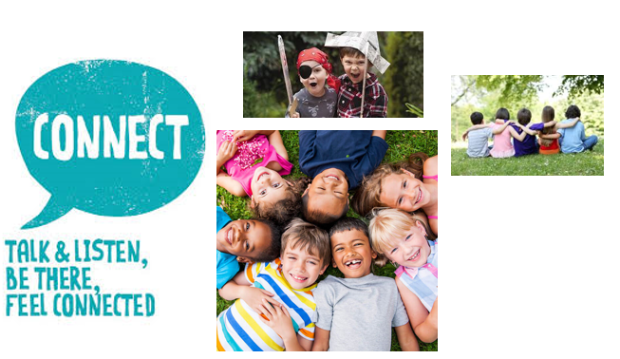



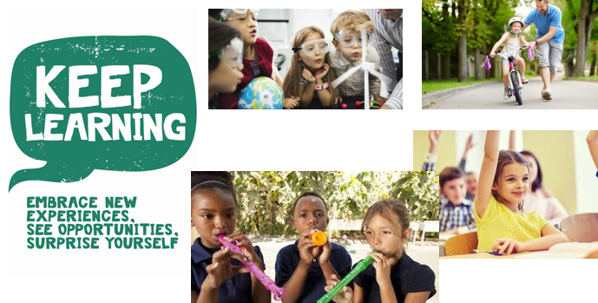



Why is it important to get a good night’s sleep?

