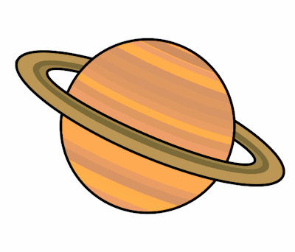
Planet Spellings
Week beginning 2nd November
(Homophones)
know
no
write
right
great
grate
main
mane
heel
heal
break
brake

