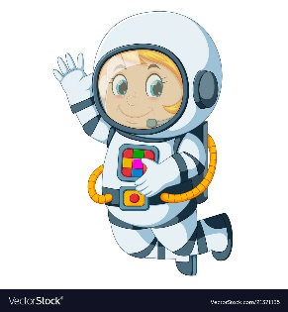
Astronaut Spellings
Week 2 20.9.21
perfect
imperfect
correct
incorrect
happy
unhappy
safe
unsafe
patient
impatient

