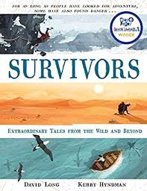
Today I would like you to continue the recount as you think it might have happened. Your version can begin like this…
By this stage in the expedition the men were hundreds of miles from anywhere…

