North Stainley C of E School
NEWS FROM THE HEADTEACHER

Newsletter 3 Spring term 2019
Wednesday 20th March 2019

Dear parents / guardians,
We are having a very busy half term here at school. It was good to see so many parents at parents’ evening .

RURAL SCHOOLS CHARITY CONCERT – FRIDAY 22nd MARCH – ROYAL HALL HARROGATE
The concert date is nearing and we will be practicing our songs every day so that the children are confident. The number of children going has grown to 24 so we have a lovely sounding choir.
It would be great to see lots of parents supporting us in the audience, please buy your tickets from the box office. It is a great cause and it really is the stuff from which memories are made.

NEW WEBSITE
The creation of our new website is nearing completion, very exciting. We will keep you up to date with developments..
WORLD BOOK DAY –author visit.
Thank you for making so much effort with your children’s costumes for World Book day. I do hope the vouchers for a free book or £1 off another book have been used with excitement. A couple of children have shown me books they have purchased.
We had an author visit on Friday, he was very funny and engaging. Hopefully the children got lots out of it.

SCHOOL AMBASSADORS – REDUCING WASTE AND SINGLE USE PLASTICS – FANTASTIC NO PLASTIC!.
VISIT TO ALLERTON PARK
Finn and Isobel (our school ambassadors) and I went to Allerton Park Waste Recycling Centre on Monday. It was a fascinating visit and horrifying to see how much waste we produce.
We are continuing with our Fantastic-No Plastic ! campaign with the rural cluster.
Please think about how you pack your children’s lunch. We are now recycling crisp packets so please bring them along and we’ll take them to be recycled.
We’ve written to local TV stations and newspapers. Other schools have contacted supermarkets, our MP and the local radio station.

ATTENDANCE
Please remember how important it is that your child attends school every day. We start teaching at 8.50 , the doors are open from 8.45am.
If your child is ill please ensure that you contact school on the first morning off absence via telephone or email.
Attendance from September to Spring Term 1 –

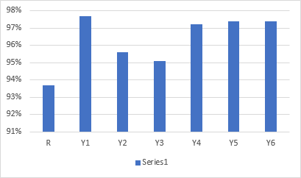

Our target for attendance is 98%.
If your child’s attendance is less than 95%, this is a cause for concern as they are missing a significant amount of school. If your child is late after registration it is classed as unauthorised absence for that session.

SUNDAY 17th MARCH -LIGHTWATER VALLEY CHALLENGE
Thank you all so much for the amazing teamwork that the families, children and staff put in to make this year’s event a resounding success. Thanks to our FONSS members, especially Sarah MacGavin and Sally Taylor- who were amazing and put in so much hard work. Lots of money was raised – which is great news for the school.
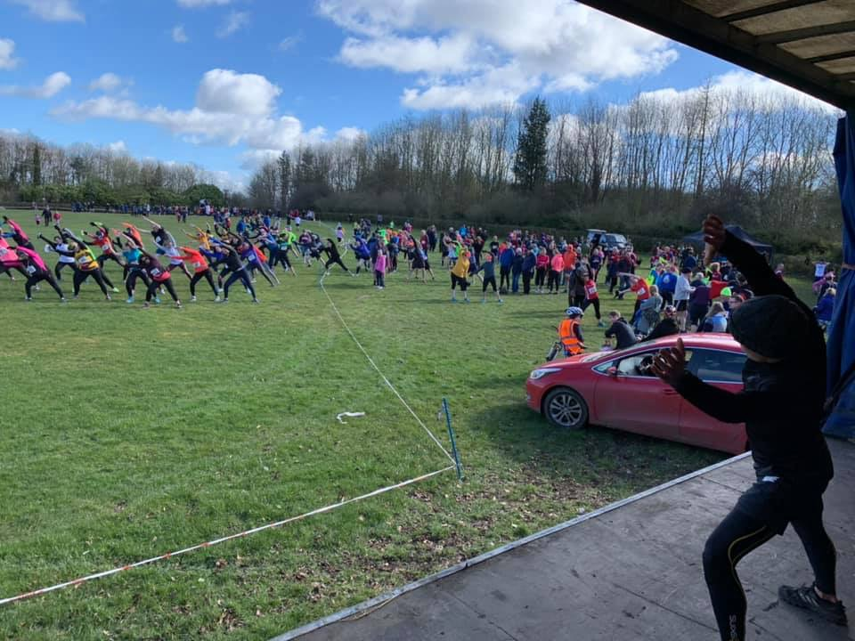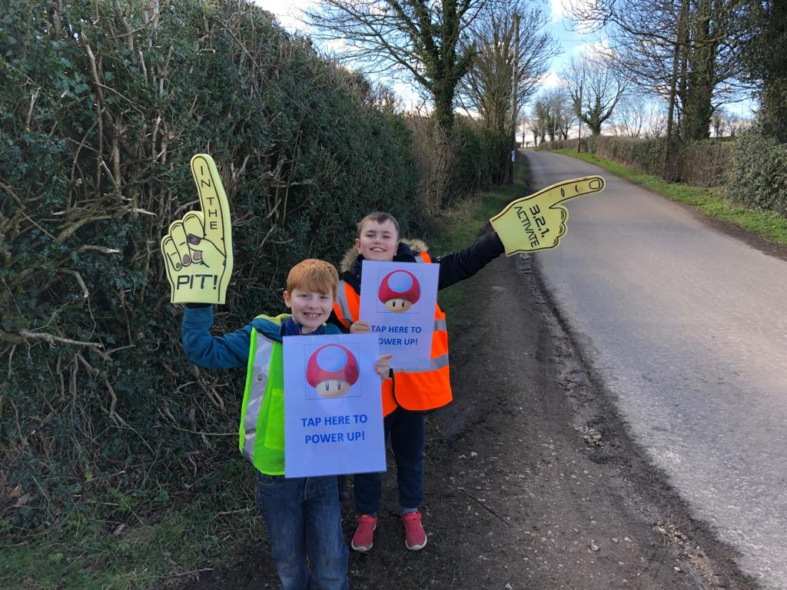
FEAST FRIDAY
Feast Friday continues on Fridays. Put your orders in for our delicious treats and help support our school. Thank you.

APPIONTMENT OF A NEW HEADTEACHER
I know many of you will be wondering about the outcomes of the interviews on Tuesday and Wednesday of this week. We were lucky enough to have three fantastic interviewees who were all employable. The governors were unanimous in their decision and have offered the post subject to satisfactory checks and the applicant has accepted. We can’t give you any further details until all statutory checks have been successfully completed.

EASTER EGG DECORATING COMPETITION – Thursday 11th April – a Famous Character from History
On the last day of term we will be holding an Easter Egg decorating competition. The children are asked to bring in a boiled egg decorated in the theme – A Famous Character from History .
We will also be holding our annual Easter Egg drop competition for the children in school.

DATES FOR YOUR DIARY

Friday 22nd March – Rural School Concert at Harrogate Royal Hall 6.30pm
Thursday 28th March 5pm Spring Production –Class 3 lead
Thursday 4th April – Football Y1/Y2
Tuesday 9th April – School Ambassadors meeting
Thursday 11th April –Break up for Easter 2.30
Thursday 11th April –French Trip meeting at Bishop Monkton 6pm.
Friday 12th April – teacher training day.

Please contact me if you have any concerns or comments,
Kind regards,
Mrs Elizabeth Watts
Heateacher.

