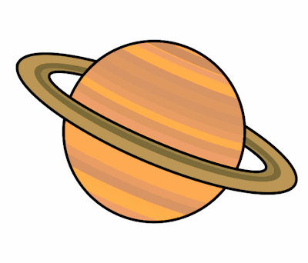
Planet Spellings
Week beginning 23rd November
machine
chute
parachute
chef
brochure
chandelier
pistachio
charade

