**The Invasions!**

**60 BCE the Roman Empire is expanding**

The Romans now control many countries around the Mediterranean Sea including Greece, Turkey, Spain, the coastal regions of North Africa and much of France (that they call Gaul). Their power continues to grow.

**55 BCE the Roman General Julius Caesar visits Britain**

Julius Caesar comes with 10,000 troops. The Britons are fierce and attack with their chariots. He leaves after 3 weeks but returns a year later with 30,000 troops. This time the Roman army win battles but the Britons do not give up. Julius Caesar leaves Britain after 12 weeks and returns to Gaul with stories of Britain. It is a land rich in tin, copper and iron where crops grow well and the people fight fiercely!

**43 CE the Roman Emperor Claudius Invades Britain**

Claudius wants to make the Roman Empire even bigger. He needs silver and gold from British mines as well as the good farmland and other valuable metals. He sends an army of 40,000 troops to conquer the country. They are led by General Aulus Plautius. This time they intend to stay!

Class 2- History Knowledge Organiser Spring Term, Year A

Why Did The Romans Settle in Britain?

Key Knowledge

* Understand what was life like in Iron Age Britain before the Romans came.
* Understand how the Roman Empire expanded and in what areas.
* Know when the Romans invaded Britain and something about why.
* Know that we can learn about the daily life of people in Roman Britain from the evidence they left behind.

Key Vocabulary

**Druid:** priest of the Celtic religion.

**Celts:** the people who lived in Britainbefore the Romans came

**Invasion**: One country attacking another to take it over.

**Emperor:** The leader of an Empire, Similar to a King or a Queen.

**BC:** Before Christ (Before the year 0000)

**BCE:** Before the Common Era (Before the year 0000)

**CE**: Common Era (After the year 0000)

**AD**: Anno Domini (After the year 0000)

**Rebellion**: an act of armed resistance against a ruler.

61CE

Boudicca leads a rebellion

43 CE

Emperor Claudius invades Britain.

54BCE

Julius Caesar returns.

55 BCE

Julius Caesar attempts invasion.

60 BCE

The Roman Empire is expanding.

600 BCE

Celtic tribes settle in Britain from Europe.

800 BCE to 43 BCE

**Celtic Houses**

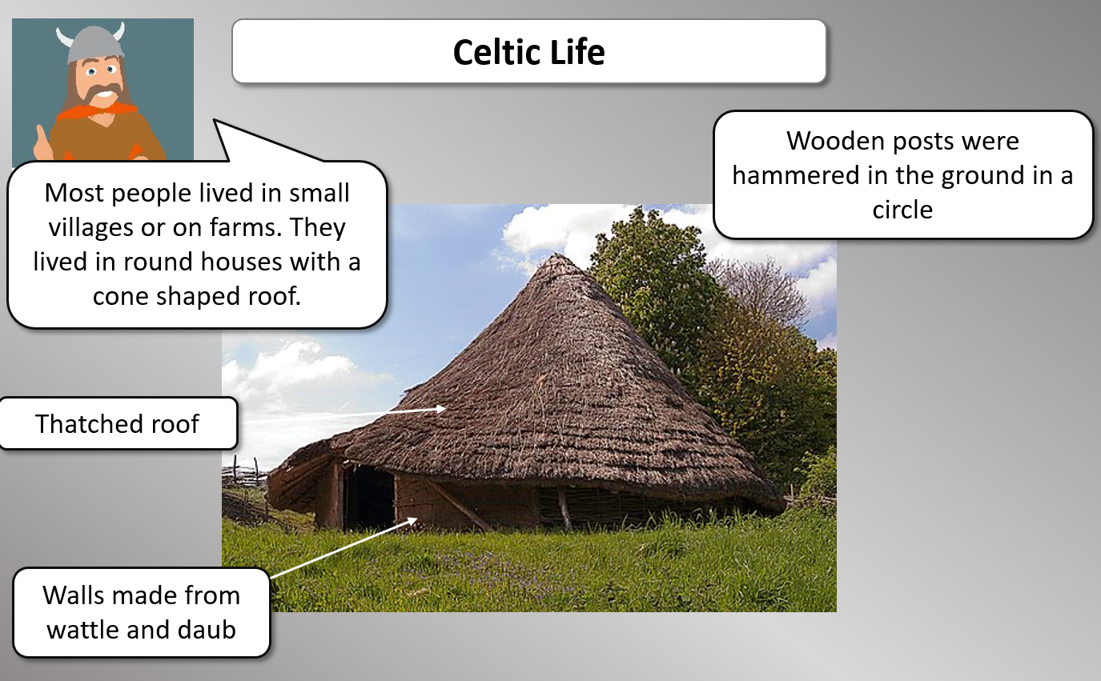

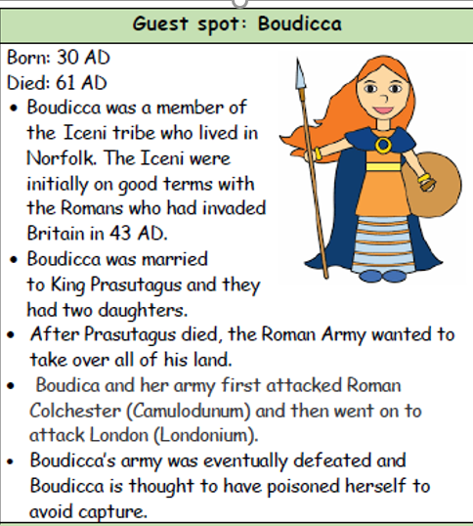

**Choosing a place to live:**

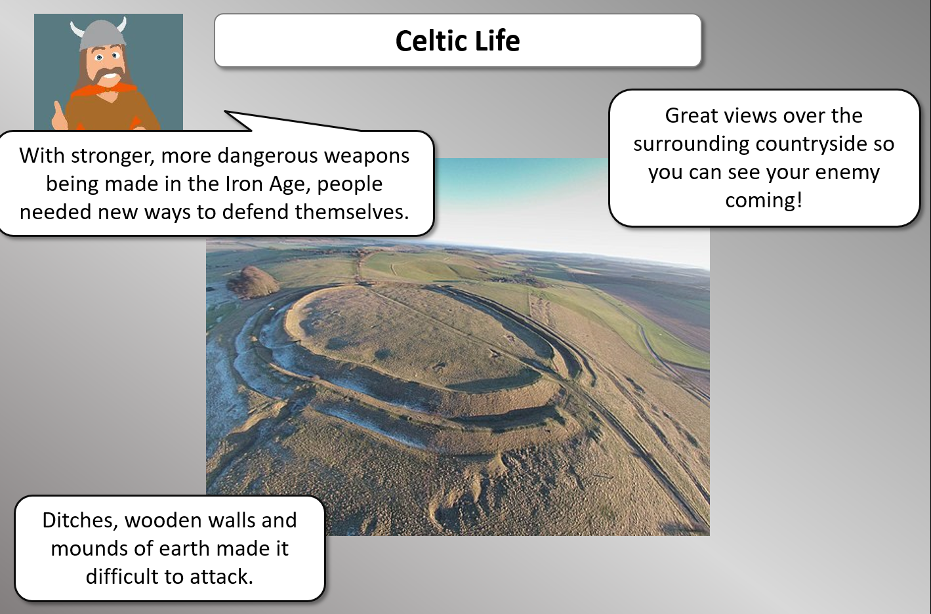

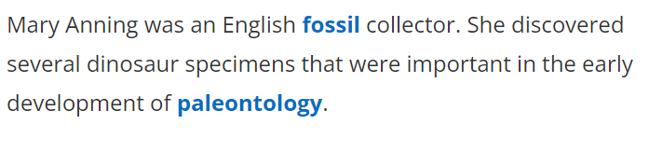

**Celtic Life**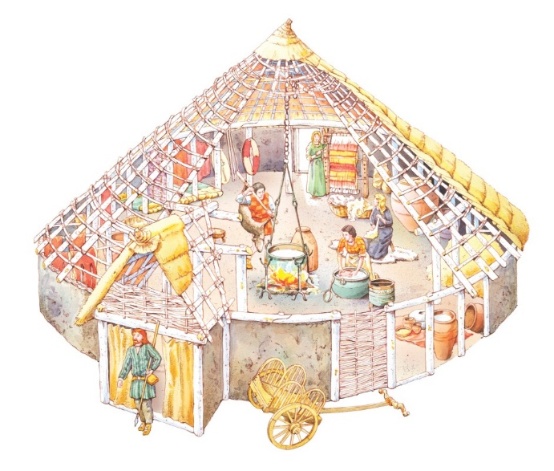

**600 BCE Celtic tribes settle in Britain**

Celtic tribes from Europe settle in Britain. They are skilled at working with iron so this time becomes known as the Iron Age. They build round houses and form large settlements. They are good farmers and fierce fighters. The Celts in Britain become known as Britons.

