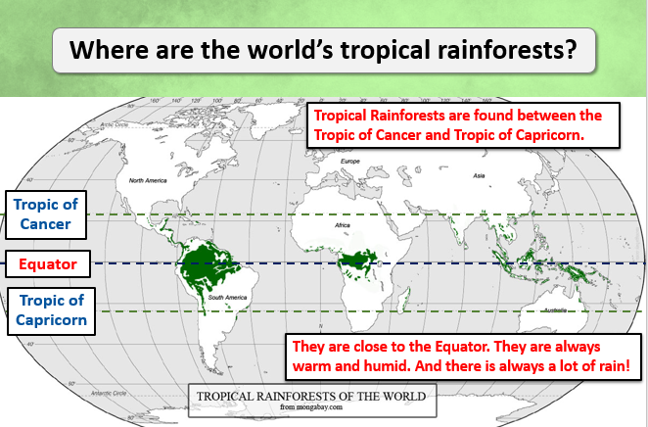

**Class 2- Knowledge Organiser Spring Term, Year B**

**Why are Rainforests important?**

**Key Vocabulary**

**Equator:** imaginary line around the middle of the Earth.

**Line of Latitude**: imaginary lines that divide the Earth East to West (horizontally)

**Line of Longitude**: imaginary lines that divide the Earth North to South.

**Tropic of Cancer**: The most northerly Line of Latitude which the sun can be directly overhead.

**Tropic of Capricorn**: The most southerly Line of Latitude which the sun can be directly overhead.

**Emergent Layer:** the topmost layer of the rainforest.

**The Canopy**: the upper layer of the rainforest formed by the branches and leaves of mature trees.

**The Understorey Layer**. Layer of small trees, plants and bushes.

**The Forest Floor**: The lowest layer nearest the ground.

**Deforestation**: The clearing or cutting down of the Rainforests.

Key Knowledge

Tropical Rainforests are found close to the Equator, between the Tropic of Cancer and the Tropic of Capricorn.

The Amazon rainforest is in South America.

The climate in tropical rainforest regions is hot, humid and wet*.*

There are four layers of a rainforest: emergent layer, the canopy, the understorey layer and the forest floor.

I can tell you about the climate in each layer.

I can tell you about the plants found in

each layer.

I can tell you some animals that live in each layer.

I can name some foods and products that come from rainforest plants.

I can name some rainforest plants that are used in medicine.

I can explain some of the reasons why the rainforests are under threat

