Duction.

Key Vocabulary

Invader: someone who enters by force in order to conquer.

Settler: a person who moves to a new place intending to stay there.

Anglo-Saxon: a mix of tribes from Germany, Denmark and The Netherlands.

Kingdom: a country or land ruled by a King or Queen.

Boss: A piece of metal in the centre of a shield.

Scabbard: a piece of leather used to hold a blade/ sword.

Dyke: a structure built by King Offa to defend his Kingdom.

Reign: The length of time a King or Queen rules a land.

There were 7 Anglo-Saxon Kingdoms: Northumbria, Mercia, Wessex, Sussex, Kent, Essex and East Anglia

Class 2- Knowledge Organiser Autumn Term 1, Year B

**Why did the Anglo-Saxons come to Britain?**

Key Knowledge

I can explain the meaning of ‘Invaders and Settlers’ and talk about the difference between them.

I can explain why the Anglo-Saxons came to settle in Britain.

I can explain what natural resources would make a good site for a settlement.

I can describe the appearance of an Anglo-Saxon warrior.

I can name some of the Anglo- Saxon Kings.

I can talk about King Offa and tell you about something he did.

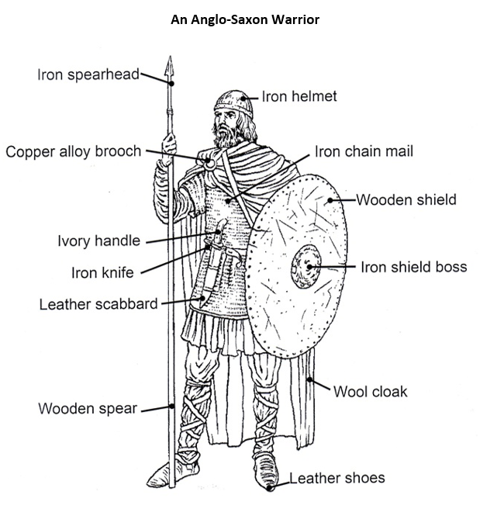

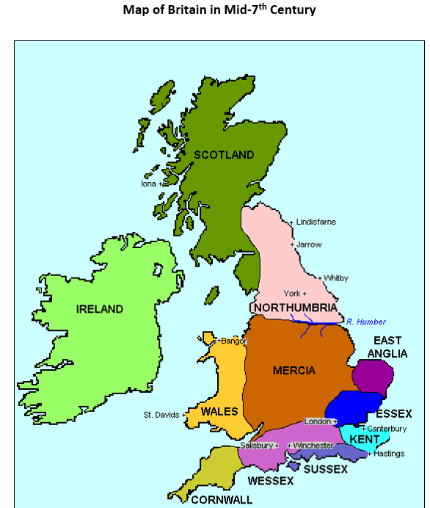

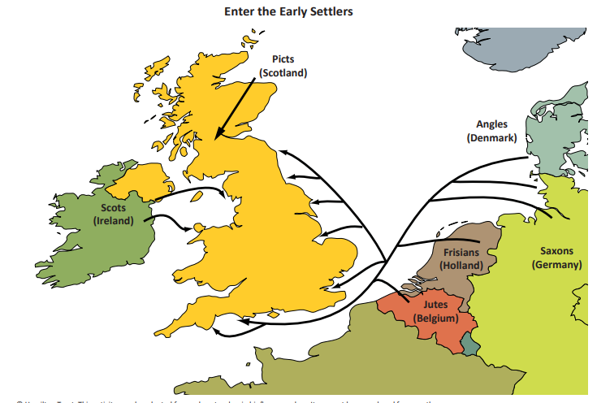

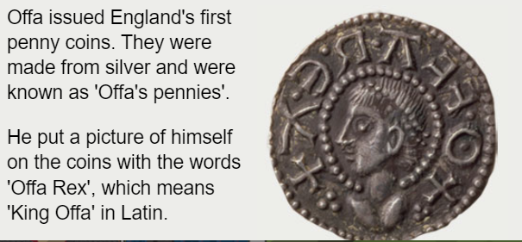

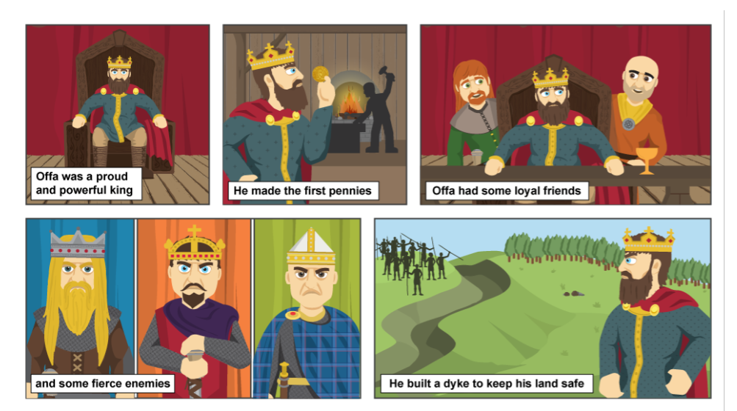

Offa built a dyke to keep his land safe.

