Duction.

Key Vocabulary

Facial Features: eyes, nose, mouth.

Emotions: feelings.

Expression: how the face shows emotion.

Body language: The way the body shapes itself to show emotion.

Cartoon style: a simple drawing that tells a joke or story

Illustrator: an artist who draws pictures in a book.

Gesture Lines: Lines that show movement and expression.



Class 2- Knowledge Organiser Art Spring 1, Year B

Can I show how a character is feeling from facial expressions and body language?

Key Knowledge

Facial expressions and body language can show how a character is feeling.

Quentin Blake is a famous artist and illustrator.

Quentin Blake uses a cartoon style in his drawings.

I can explore lines and draw facial expressions in the style of Quentin Blake.

I can show use short lines to show body language in the style of Quentin Blake and show how a character feels.

I can plan an illustration for my story in the style of Quentin Blake

I can plan an illustration for my story in the style of Quentin Blake.

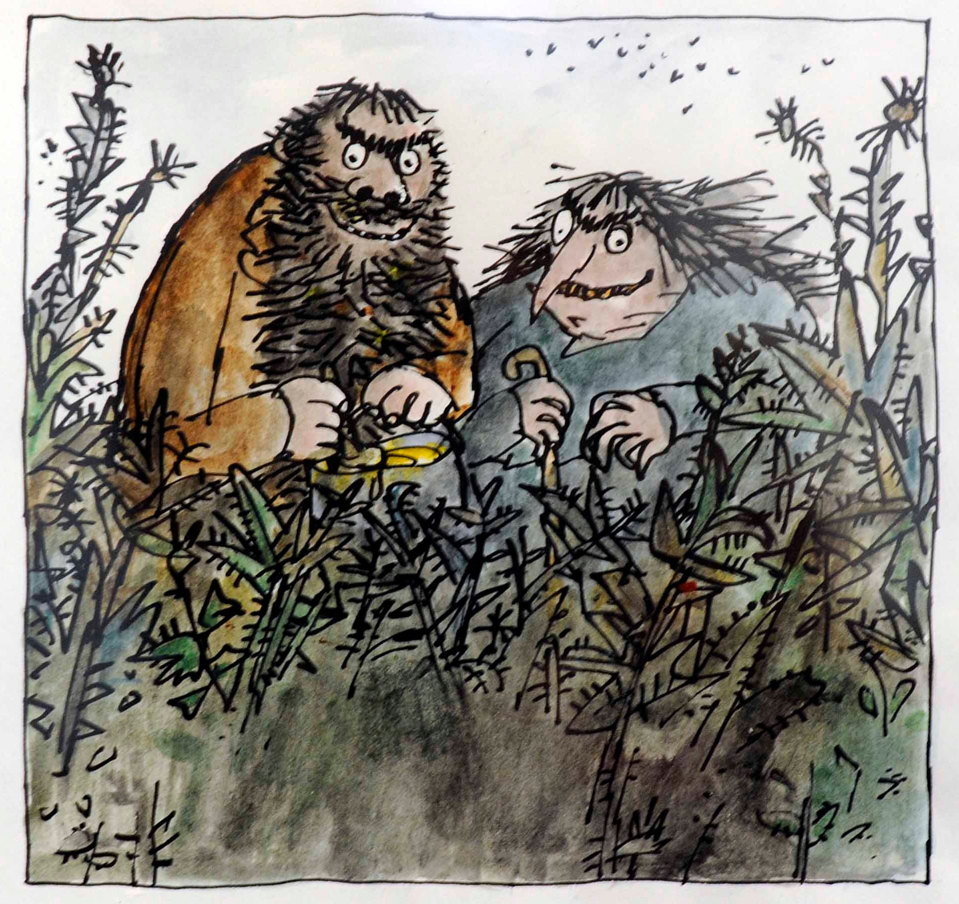

Quentin Blake is an artist and illustrator who draws in a cartoon style.

