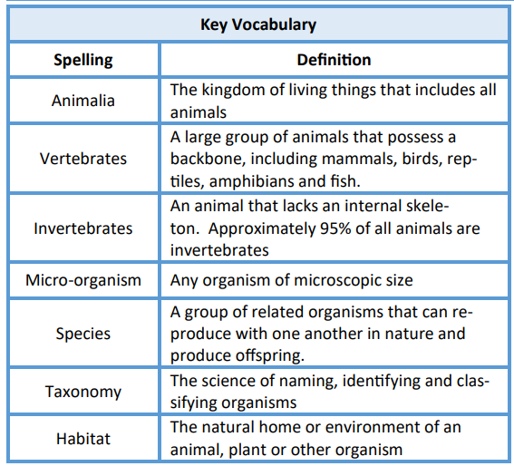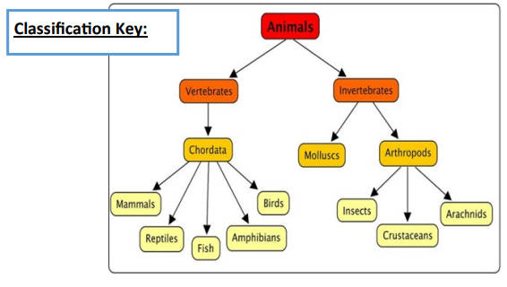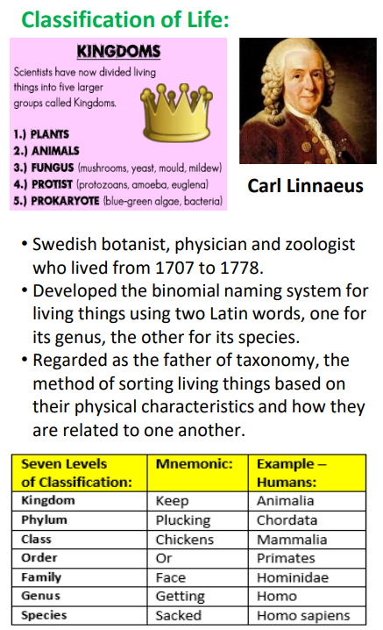

**Key Knowledge**

Know who Linnaeus was and learn about his classification system.

Understand that classification systems group living things according to similarities & differences.

To identify the similarities and differences between living things in order to determine their classification.

To use classification keys to sort living things according to observable characteristics.To develop classification keys.

To test out classification key, noting different approaches and identifying potential flaws.

To describe the key characteristics of unusual living things from around the world.

To use descriptions of features, & online research, to attempt to classify unusual living things.

To design, describe and name a new creature that characteristically sits within the Animalia classification.

To sort ‘new’ creatures within the Animalia taxonomy.

**Knowledge Organiser – The Classification Code**