Volcanoes!
Click on the link below to go to the bitesize lesson on volcanoes.

https://www.bbc.co.uk/bitesize/articles/zhjqcmn
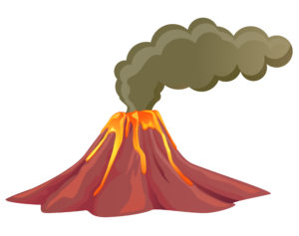
Write an information report about volcanoes.

