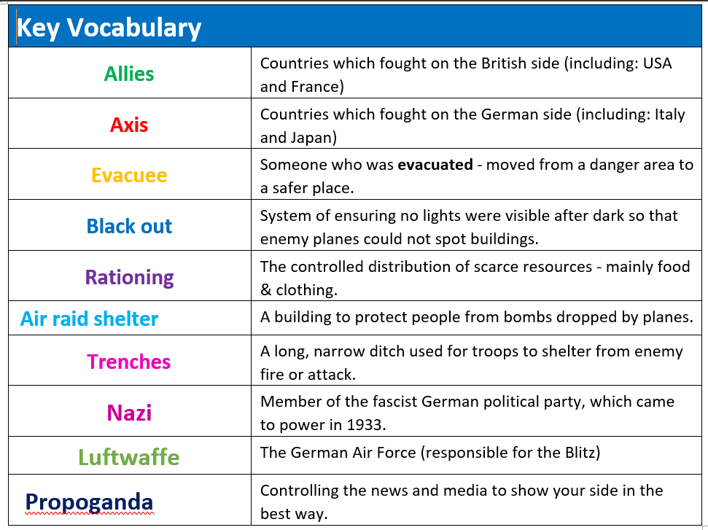**World War 2 Knowledge Organiser**

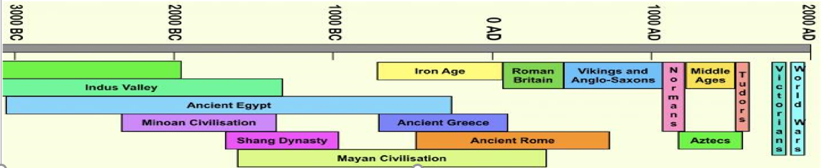

**Key Knowledge**

* Address a historically valid question related to the cause of the Blitz and its wider context.
* Inform my response through thoughtfully selected relevant information.
* Address historically valid questions related to the significance of the Blitz.
* Develop a coherent narrative of the war including a British and world dimension.
* Understand how our knowledge of the impact of the war is constructed from a range of sources.
* Address historical questions related to similarity and difference between fiction and evidence-based sources.
* Understand similarity and difference of children's experiences and note connections and contrasts over time.
* Explore different conflicts from the past and discuss how it is more or less dangerous than The Blitz.

