English Homework Week 4

Read these riddles and write the answer (they rhyme). Then write your own riddle.

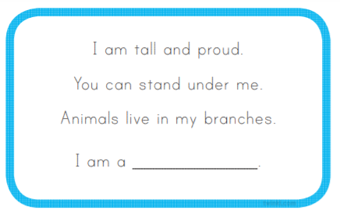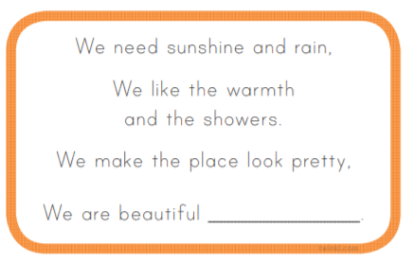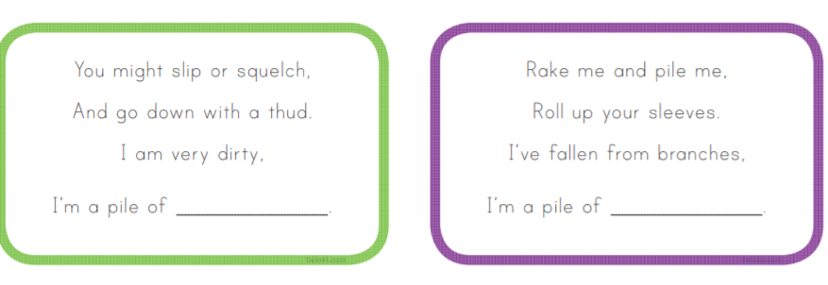

Write your own riddle here: (We will try and solve them in class.)