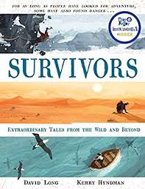
- Read page 10, ‘The man who came home alone,’ up to near the bottom of page 12, ‘…there was still the problem of where to find food.’
- Why was Douglas Mawson in Antarctica?
- What skills did each of the three men have?
- Why did the men only manage to travel a quarter of the distance they intended after six weeks?
- ‘Wind speeds in Antarctica can hit nearly two hundred miles an hour.’ What problems did this pose for the men?
- What were the most important issues the men had to deal with after losing their friend?
- The men felt that they only had one option at this point in the story, which was to turn back to camp. Can you think of any other options they could have taken?

