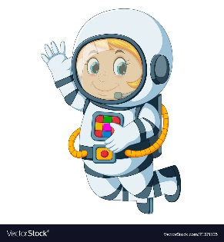
Astronaut Spellings
Week beginning 1st February
there,
their,
no,
know,
right,
write,
to,
too,
week,
weak,

