(We have just completed our Addition and Subtraction unit, so have a go below to consolidate!)
Use this sheet to work on accuracy, fluency and recall! What methods could you use?
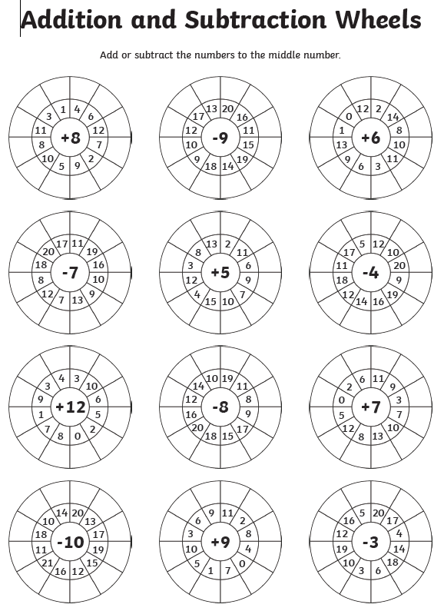
Fingers, number line, concrete resources, counting in your head, hundred square…

