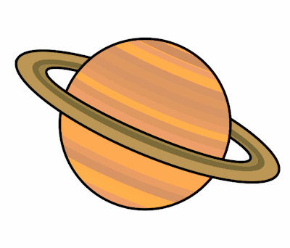
Planet Spellings
Week 1 4/1/22
Unit 12
regular
irregular
relevant
irrelevant
responsible
irresponsible
resistible
irrisistible

