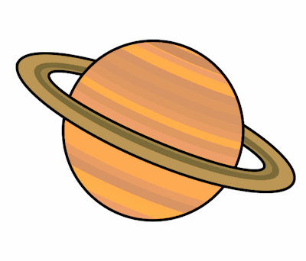
Planet Spellings
Week beginning 19th July
early
earth
eight
eighteen
eighth
enough
exercise
experience
experiment
extreme

