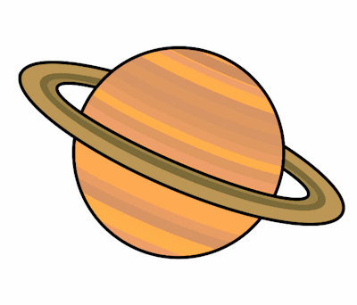
Planet Spellings
Week beginning 7th December
magic
magician
optic
optician
music
musician
electric
electrician
mathematics
mathematician

