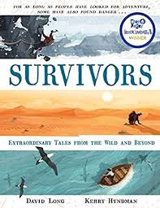
- Read from page 38, ‘Flashing the beam of a torch…’ to the end.
- What did the two men decide to do first after they had surveyed the chaotic scene around them?
- Why do you think some of the sentences from the text have been written again in blue, slightly bigger font?
- How did the men make the best use of their limited oxygen supply?
- Why do you think the men did not touch the sandwich until later on in their experience?
- Chapman and Mallinson were made aware of the rescue efforts going on above them. After seventy-two hours, how do you think the men were feeling and why?
- If you were Mallinson, would you have been happy to be trapped with Chapman? Why?
- When the men finally reached the surface, why were they still not out of danger?
- This ordeal occurred in 1973, how do you think the two men still suffer from it even today?

