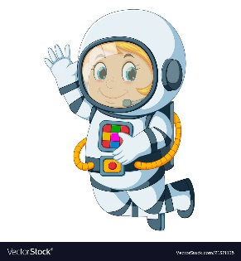
Astronaut Spellings
Week 5 31st January
hero
superhero
woman
superwoman
glue
superglue
star
superstar
sonic
supersonic

