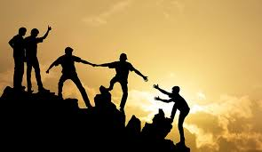
What does this image make you think about?
Can you describe what is going on?
Does it remind you of a situation you know about or have been in yourself?

