A Message in A Bottle
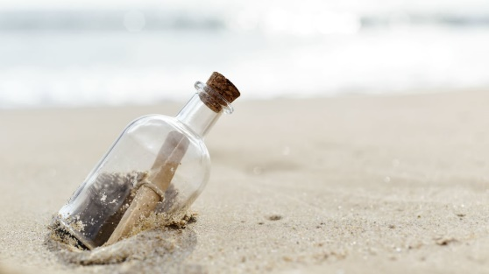
Think of something that you have done really well this year and makes you proud:

What would you like to focus on in September to help you to flourish?

Put your message in a bottle and bring it to school on the first day back.

