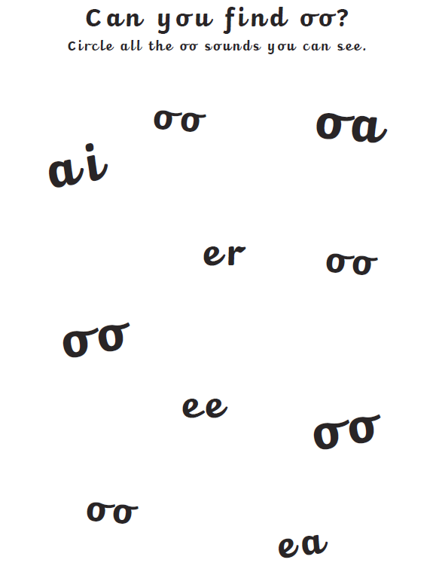
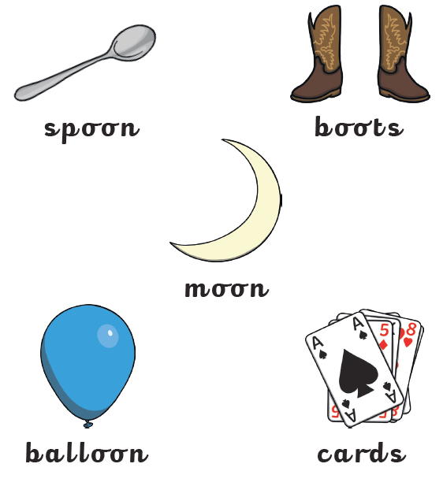

Can you think of any more oo words? Maybe you can go on an oo hunt looking in books and magazines around the house!

Sentence writing
Can you write some different sentences below with an ‘oo’ word in?











