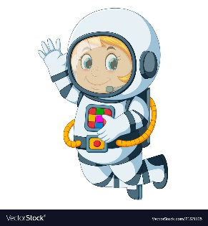
Astronaut Spellings
Week beginning 28th September
face
race
ice
price
slice
mice
rice
pencil
police
city

