Self Isolation Work
Week Beginning: 23/11/2020
Year Group: Reception

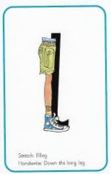
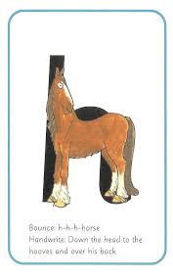
Phonics:
This weeks sounds: l and h
l: Up the leg, down the leg and don’t forget the toes!
h: Up the horse, down the horse, up and over his back.
Practise saying the rhyme, writing the letter in different ways- magic finger, in a bowl of rice, chalks, pens, tablet screen
Can you find things beginning with these letters?- draw them! Can you find these letters around the house, in your book, is this letter in your name?
Using the letters below, make some CVC words to practise Freddy Fingers!
m a s d t i n p g o c k u b f e l h
Maths:
This weeks mathematics focus: How to Count
Number blocks video: https://www.bbc.co.uk/iplayer/episode/b08cr24d/numberblocks-series-1-how-to-count
In class, we watch the video daily at the start of each session and then have a discussion about what they saw in the video!
Back on the page you downloaded this document there are resources to aid in this weeks learning!

Writing:
We are practising hold a sentence, letter formation and completing the sentences this week.

Hold a sentence: zip it up
Letter formation focus: t p u I z s
Missing words: Zip ______ up, put them _______, lets ________. (it / on / run.)

