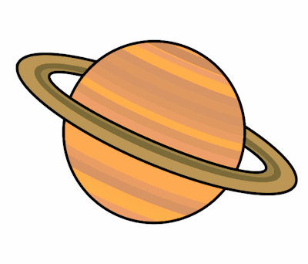
Planet Spellings
Week 4 24/1/22
Special Focus
double
trouble
enough
tough
rough
young
country

