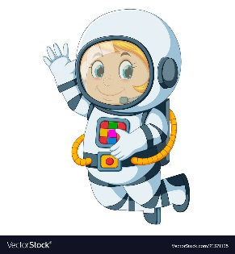
Astronaut Spellings
Week beginning 9th November
cure
pure
sure
lure
azure
mixture
picture
furniture

