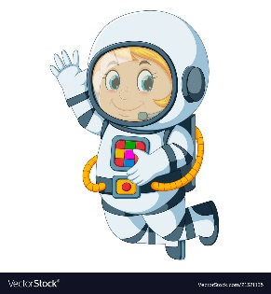
Astronaut Spellings
Week beginning 19th October
bird
whirl
twirl
first
third
thirteen
thirty
skirt
shirt
thirsty

