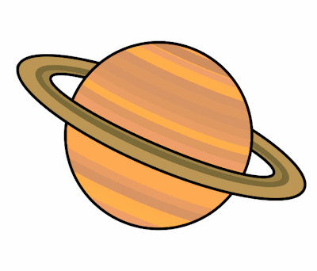
Planet Spellings
Week 12 29/11/21
illegal
disagree
impolite
illogical
reappear
unclear
reappear
illegible
incomplete
incorrect

