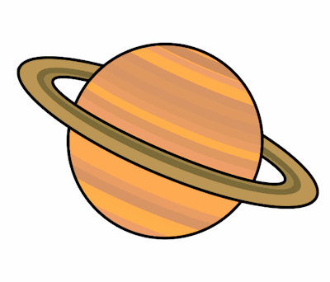
Planet Spellings
Week beginning 9th November
(adding ation to verbs)
tempt
temptation
inform
information
explain
explaination
sense
sensation
prepare
preparation

