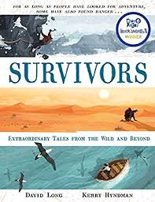
- Read from page 12, ‘Mawson felt there were two courses…’ up to, the bottom of page 14, ‘…while drifting in and out of consciousness.’
- The author uses the phrase, ‘supplement their rations’ on the bottom of page 12. What does he mean by this?
- Why did Mawson suggest that travelling at night would be a better option?
- The author writes that, ‘On long expeditions it’s often only the thought of a break and a hot meal that keeps explorers pushing on.’ Mawson and Mertz did not have that to look forward to so what do you think made them keep pushing on?
- At the top of page 14, the author writes about the ferocity of the returning Antarctic winter. Why would this be of concern to the scientists?
- Mawson, at the bottom of page 14, ‘found what he needed’. What did he find?
- What thoughts do you think were running through Mawson’s head as he was drifting in and out of consciousness?
- This experience happened over a century ago. Do you think it would have made any difference it had happened nowadays? Explain.

