North Stainley C of E School 2023-24

To ‘love learning’….
Homework supports the links between home and school, providing parents with opportunities both to support their children as they learn and to become more closely involved in that process.

We aim to develop a consistency of approach throughout the school that will enable our children to progress towards independence and individual responsibility.

Type and amount of homework...

Regular reading to and with an adult is vital! We want our children to become fluent readers who have a joy of reading and a love for all types of books and texts.
Challenge: - We also want our children to challenge themselves in their reading trying various genres of fiction and non-fiction reading. Sharing what they have learned through book reviews and short written or verbal summaries. See our school’s Reading Booklet for support with reading expectations and strategies.
Reading Booklet
All KS1 children should either read to their parents or carers, be read to by their parents and carers, or a mix of both for between 10 to 20 minutes a day. KS2 children may wish to read independently. All parents should question their child/ren to ensure they have a good comprehension of the text. KS1 reading scheme books have relevant questions at the back of each book.
Each child will have a Reading Record Book. KS1 parents must ensure that they complete a section of this Reading Record and date it each time their child reads. Children in KS2 may complete their Reading Record independently but there is an expectation that parents will monitor and ensure that this is being completed correctly.
Reading homework will be assessed at least once a week across the school and when necessary feedback will be given in the reading record book.

Spellings target to be achieved weekly. Each child from Year 2 will have a Read Write Inc spelling log book. Each page of this book provides the spellings the children are learning that week and a related explanation of the spelling rule/ pattern, as well as some previous spellings that need reviewing. Parents should ensure that their child is given the opportunity and support to learn their spellings and are able to spell both verbally and in writing.
Challenge: - Children can be challenged in their spellings by finding other words that include the pattern they are working on. Children may also like to look at the etymology (definition and meaning) of these spelling words.
Children will be tested on their spellings each week; the day of the spelling test may vary depending on the class. Class teachers will add class homework information to the homework tab on their class web-site pages.

Maths fluency targets. Maths fluency targets will be identified through the ‘Maths Passport’ progressive scheme. The passport will provide each child with a target and a worksheet to match this target, the expectation is that the children will complete a number of questions in a set time - Some children may be given individual times to complete the questions.
Challenge: - Children can be challenged or can challenge themselves through shortening times, revisiting previous learning or using programmes such as Top marks Hit the Button….
Hit the Button - Quick fire maths practise for 6-11 year olds (topmarks.co.uk)
Children’s targets will be tested and assessed regularly. Class teachers will add related information to the homework tab on their class web-site pages - Children or parents can request testing outside of these times if required.

Literacy or Numeracy homework. Children in Years 1-4 will receive homework in one of these areas each week depending on what is being learnt in class. Year 5 and 6 will receive home work in both literacy and numeracy each week. This will be a paper copy sent home with each child in a homework book or folder.
Challenge: - a challenge may sometimes be included.

A guide to approximate time allocation
Year Group | Reading  Read with and questioning your child’s comprehension of their reading. | Spellings To practise spellings and recognise and understanding the spelling pattern and meaning of a word | Maths passport  To practise fluency targets, recognising and understanding pattern in their learning | Literacy or Numeracy homework | Optional - Foundation Subject Homework  To be completed before the end of each block (2-3 weeks)
Reception | 10 minutes daily | Sound cards (alongside reading) | Number work  (Intermittent) | N/A | This homework is optional therefore time allocation is dependent on individual’s own expectations.
1 and 2 | 10-20 minutes daily | 5-10 minutes 3x per week | 5-10 minutes 3x per week | 30 minutes per week
3 and 4 | 15-20 minutes daily  (minimum) | 10 minutes 3x per week | 10 minutes 3x per week | 40 minutes per week
5 and 6 | 20 minutes daily  (minimum) | 10 minutes 3x per week | 10 minutes 3x per week | 60 minutes per week

Foundation Subjects, Optional Homework. This is a homework relating to the foundation subject the classes are working on. (The foundation subjects ie: history, geography, art, music etc are taught in blocks of 2 to 3 weeks across all terms.) The aim of this optional homework is that the children will be able to explore these topics further by making links to one or more of the other subjects in the curriculum. - For example, a child who is learning about World War 2 may want to learn and present a piece of related poetry (literacy link). Present a song from this period finding out about how this was used to raise morale (music/pshe link). Find and explain data from the period (maths link). Draw maps and look at the different topography experienced during the war (geography link). Cook a ration recipe (DT link)
This optional homework will be marked or assessed depending on how it is presented. Children will earn extra house points for optional homework and will be given an opportunity to present their work to the class and at times to the school.
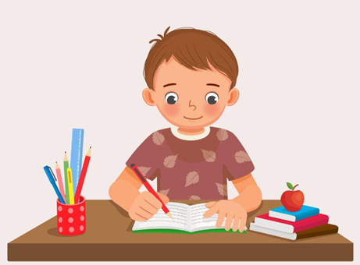
*Please see Class Homework pages on the website for individual class updates.

