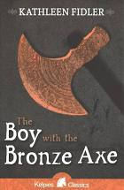

- Read the text from the book.
- Write a detailed description about the place Tenko and Birno are.
- Try hard to picture the scene by imagining what it would be like if you were there.
- Remember to use all your senses. What can you see, hear, feel, smell and taste?

