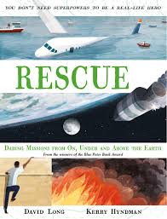
- Read from page 119, ‘Eventually, using a sort of karate kick…’ to the end.
- Now watch this: https://www.youtube.com/watch?v=nbNQEgg7FXU
- Shavarsh Karapetyan is known as a Superhero. Some people may not have heard of him. Write a news report telling them all about how he earned the title of Superhero.

