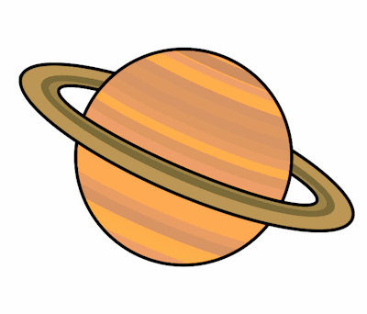
Planet Spellings
Week 5 31/1/22
Special Focus- Homophones
pair, pear
groan, grown
main, mane
reign, rain, rein
peace, piece
berry, bury

