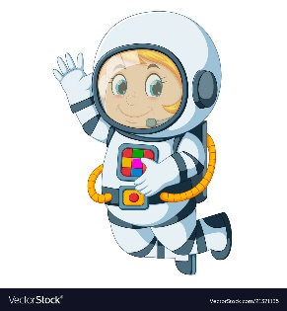
Astronaut Spellings
Week 8 1.11.21
Unit 6
sense
sensation
inform
information
prepare
preparation
explain
explanation
exclaim
exclamation

