Kensuke’s Kingdom
Chapter 6
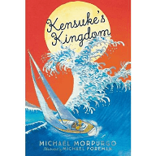
Read Chapter 6
- How did Michael feel when the super-tanker didn’t see him?
- What did Michael do to ensure that he could be seen in the future?
- Why did he keep this a secret?
- Why did Michael hate Kensuke?
- Why do you think Kensuke treated Michael the way he did?
- Why do you think Michael went into the sea after he was told not to go there?

