Children’s Mental Health Week 2022

Watch clip - Place 2 Be Support Balloon - youtube
Follow video step by step to create artwork

Support Balloon | Children's Mental Health Week 2022 - YouTube

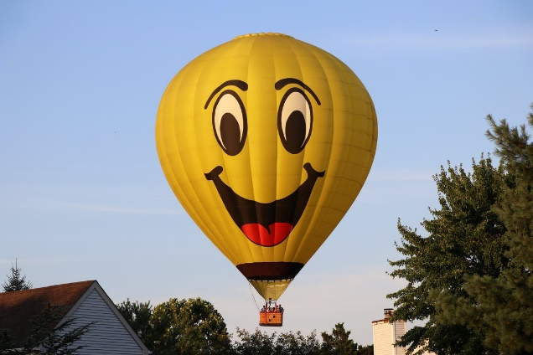

Resources
Plain paper
Coloured pens/pencils

