Key Learning
Make connections between beliefs and behaviour in different religions.
Make connections between belief in Ahimsa, Grace and Ummah teachings and sources of wisdom in the three religions.
Outline the challenges of being a Hindu, Christian or Muslim in Britain today.
Consider similarities and differences between beliefs and behaviour in different faiths.
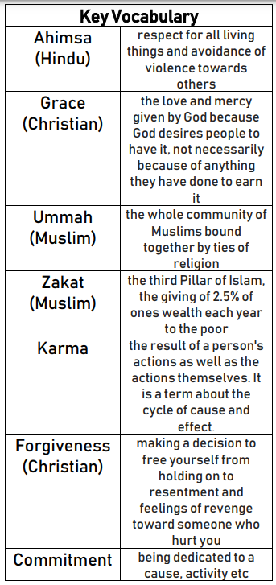
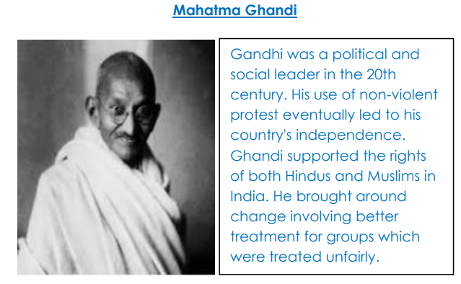
What difference does it make to believe in Ahimsa (harmlessness), Grace (the generosity of God) and Ummah (community)?

Islam – The Concept of Ummah
Ummah is an Arabic word that means community. This does not just mean a group of people from one place. Instead, in Islam, Ummah refers to the Islamic community. The people in the Islamic Ummah are from different nationalities and backgrounds who share beliefs and common purpose. The people may be far apart from each other but are united in their belief in one God, Allah.

Christianity – The Concept of Grace
Grace is the term Christians use to describe God's unconditional love for everyone, whether or not they have behaved as he wants them to. Because God's love is thought to bring forgiveness.

Hinduism - The Concept of Ahimsa
Ahimsa is often translated simply as non-violence, but its implications are far wider; it is more than not doing violence, it is more than an attitude, it is a whole way of life. The concept also includes the positive elements of working for justice, peace, liberation, and freedom, if doing so does not involve violence.
Literally translated, Ahimsa means to be without harm; to be utterly harmless, not only to oneself and others, but to all forms of life.

