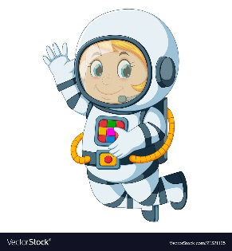
Astronaut Spellings
Week beginning 12th October
few
chew
stew
drew
crew
screw
grew
blew
threw
jewel

