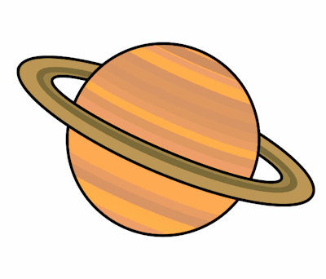
Planet Spellings
Week beginning 16th November
school
echo
chemist
scheme
character
chaos
ache
stomach
chorus
anchor

