Make Your Own Street Party!

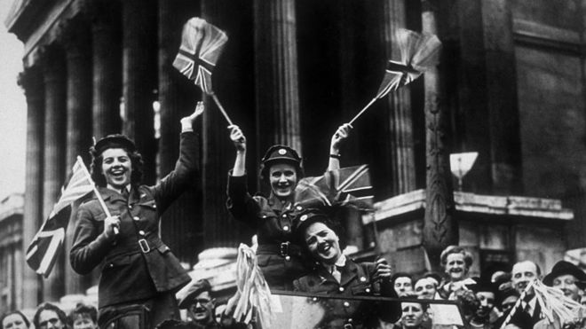

Many communities held street parties to celebrate the end of World War 2. They set tables up in the middle of their streets and had a big party. They decorated their streets with bunting and flags. Unfortunately, we can’t do that but you could make a ‘street’ party up for your family. Set out your tables in the garden, make some bunting out of paper and string and recreate the celebrations to mark the anniversary of end of World War 2. Send me photos and I will put them altogether to make one BIG street party.

