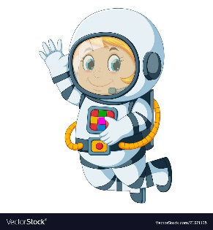
Astronaut Spellings
Week beginning 30th November
spot
spotty
run
runny
fun
funny
mud
muddy
chop
choppy

