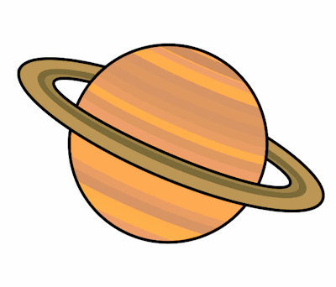
Planet Spellings
Week 2 20/9/21
measure
measurement
treasure
leisure
closure
enclosure
pleasure
weight
woman
women

